

**Blockchain**

**-**

**based**

**eCommerce**

**warranty system using NFTs**

Team Name :

Code

-

Reactors

Institute Name : RK University



**Team members details**

**Team Name**

Code Reactors

**Institute Name**

RK University

**Team Members >**

**1**

**)**

**(Leader**

**2**

**3**

**Name**

Harsh Ved

Chetan

Kochiyaniya

Utsav

Viroja

**Batch**

2023

2023

2023

**Glossary**

* NFT : Non Fungible Token
* GUI tool : Graphical user interface tool which makes easy to interact with software.
* Marketplace : It is feature of software from where users can buy / sell products.
* IPFS : Inter Planetary File System is a protocol and peer to peer network for sharing and storing data in a file system.
* Pinata : It is service which provides super fast and secure IPFS uploads.



**Use**

**-**

**cases**

•

Only Brand/Retailer can create and mint new tokens, by uploading their images and

metadata on

**IPFS**

using

**Pinata**

services.

•

Retailer sell created NFT by

**transferring**

**ownership**

to Marketplace.

•

User can

**purchase**

NFT and may also sell it by setting a price and paying a listing

fees.

•

User can

**prove**

**ownership**

of NFT.

•

User can avail warranty card in

**smartphone**

by clicking on warranty details and then on

send Receipt.

•

Warranty card with unique

**serial**

number and description is created to take

**benefits**

when product is damaged and could be replaced during

**warranty**

**period**

.



**Solution statement/ Proposed approach**

•

Retailer

**creates**

NFT

by

adding

all

the

necessary

details

of

product

.

•

NFT

card

shows

who

are

the

**creator**

,

**owner**

and

**seller**

(

at

the

time

of

selling)

.

•

NFT

is

listed

for

**sell**

by

defining

price,

and

by

transferring

**ownership**

to

marketplace

.

•

On

every

purchasing,

selling

and

transferring

nominal

transaction

**fees**

is

applied

.

•

Warranty

card

is

**generated**

on

purchase

of

NFT

.

•

Warranty

card

contains

unique

**serial**

number

and

description

of

benefits

which

can

be

**claim**

by

users

before

**expiration**

of

warranty

.

•

Warrant

card

can

be

transfer

to

user’s

smartphone

by

adding

**email**

.



**Solution statement/ Proposed approach**

•

User

can

**sell**

NFT

same

as

retailer

by

transferring

ownership

to

**Marketplace**

and

defining

selling

price

.

•

Retailer/User

can

**cancel**

or

**delist**

NFT

from

selling

if

they

are

the

seller

.

•

Retailer

who

creates

NFT

can

**find**

the

owner

of

NFT

and

on

what

price

it

is

purchased

from

othe

r

seller

but

**can’t**

perform

any

**actions**

.

•

User

can

**sell**

NFT

during

warranty

**period**

.

•

**100**

%

transparency

and

**no**

**falsifiable**

document

of

warranty

is

created

to

take

advantage

.

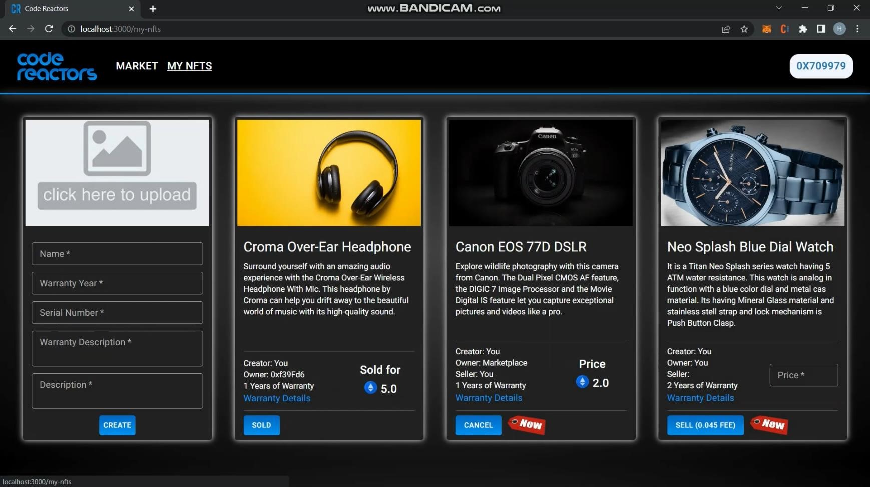Retailer Account

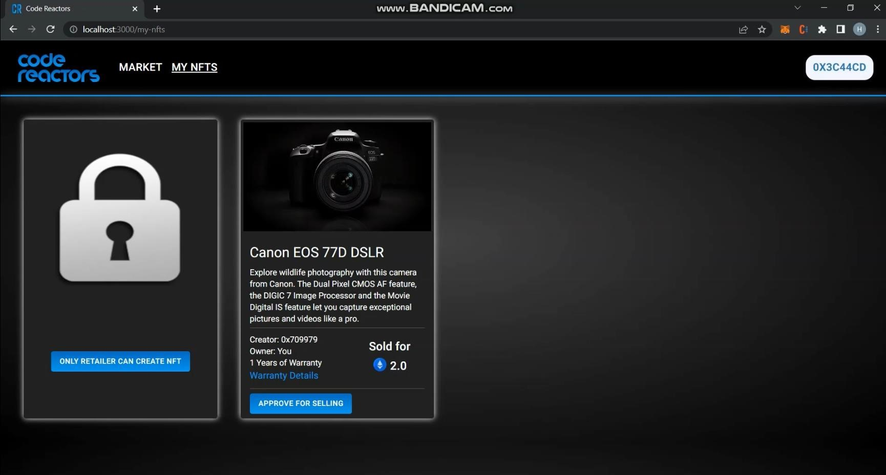User Account



**NFT Card Description**

•

Each NFT contains following details :

•

Image of product

•

Name of product

•

Description of product

•

Creator of NFT

•

Current owner of NFT

•

Seller of NFT (when selling product)

•

Warranty card contains:

•

Unique serial number

•

Warranty Description

•

Date of Generation/Expiry

•

Price at which NFT last sold

•

Button for Sell/Buy/Approve

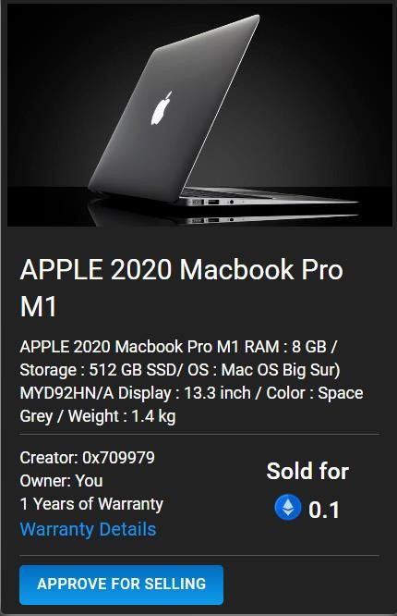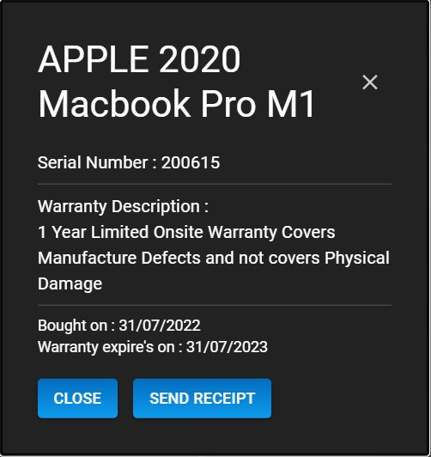

**Limitations**

•

Can

**not**

**extend**

NFT warranty.

•

NFTs are created

**manually**

by retailer/brand.

•

**Gas**

value price is higher.

•

Can not add the price

**discounts**

and coupons.

•

Anyone cannot become retailer. if you want to, than you can

**approach**

platform/service

owner



**Future Scope**

•

Provide

**verified**

symbol to verified brand/Retailer.

•

Dynamic GUI with

**login/register**

functionalities with different accessing panels.

•

**Auto**

**design**

NFT for logo of product or brand.

•

Subscription based

**events**

will be provided (e.g. Auctions)

•

Warranty

**extended**

features.